**A**

**PROJECT REPORT**

**ON**

**“Toll Tax Management System”**

Submitted By

**Mr.Thitame Harshal Shivaji**

**Mr.Ekhande Saurabh Suresh**

Guided By

Mr.Kawade Sir

In partial fulfilment of the award of the degree

of

**T.Y.B.Sc. (Computer Science)**

**of**

**S.N. Arts, D.J.Malpani Commerce & B.N Sarda Science College Sangamner,**

**DURING ACADEMIC YEAR**

2019-2020



**SHIKSHANPRASARAKSANSTHA’S** Ph. (02425) 225893 (0)

SANGAMNER NAGARPALIKA ARTS,Resi- 225164 (R)

D.J. MALPANI COMMERCE & Fax – (02425) 225893

B.N. SARDA SCIENCE COLLEGE (Id No. PU/AN/ASC/03/1961)

SANGAMNER-422605 Dist –A.NAGAR•NAAC Re-accredited College (A+ Grade)

“Spread knowledge unto the last” • Pune University Best College

E-mail: – [sangamnercollege@rediffmail.com](mailto:sangamnercollege@rediffmail.com) Award 2002-03

[www.sangamnercollege.edu.in](http://www.sangamnercollege.edu.in) •DBT Star College, DST-FIST

Date: / /

***CERTIFICATE***

This certificate is awarded to Mr.Thitame Harshal Shivaji of **T.Y.B.Sc. (Computer Science)** in appreciation of his meritorious performance as practical requirement of B.Sc. Computer Science by Savitribai Phule Pune University during academic Year 2019-2020.

***Project Guide* *Head of Department***

***Internal Examiner External Examiner***

**INDEX**

|  |  |
| --- | --- |
| **Sr.No.** | **Title** |
| 1. | Acknowledgement. |
| 2. | Introduction. |
| 3. | Objectives of System |
| 4. | Preliminary Investigation |
| 5. | Feasibility Study:  1)Operational Feasibility  2)Technical Feasibility  3)Economical Feasibility |
| 6. | Requirement Analysis. |
| 7. | Scope of Project |
| 8. | Data Dictionary |
| 9. | Entity Relationship Diagram |
| 10. | Data flow Diagram |
| 11. | UML Diagrams:  1)Class diagram  2)Object diagram  3)Use case diagram  4)Activity diagram  5)Sequence diagram |
| 12. | Coding |
| 13. | Input/output Screens |
| 14. | Future Enhancement |
| 15. | Advantages |
| 16. | Conclusion |
| 17. | Bibliography |

**ACKNOWLEDGEMENT**

A few words of gratitude to be inserted with project “**Toll Tax Management System ”**. It is our earnest duty to express our thanks to all those who contributed directly or indirectly to our project.

Firstly we would like to thank **S. N. Arts, D. J. Malpani Commerce & B. N. Sarda Science College, Sangamner and Department of Computer Science** for giving us an opportunity. Thanks to **Prof.Laddha R. S. Vice Principal,Head of Department** for his encouragement and valuable guidance.

We would like to thank **Mr**.**Kawade S.N., Mrs Talnikar H.V. &Miss Gite D.P.,** who initiated us to complete this project and guided us timely. It’s our privilege to express our gratitude to **all staff members & non-Teaching Staff members** for their excellent suggestions and active co-ordination.

And last but not least, we would like to thank all **our friends** for their support and the timely help.

Yours Sincerely,

**Mr.Thitame Harshal Shivaji**

**T.Y.B.Sc.(Computer Science)**

**INTRODUCTION**

Toll Tax Management System is a web based application that can provide all the information related to toll plazas and the passenger checks in and pays the amount, then he/she will be provided by a receipt. With this receipt he/she can leave the toll booth without waiting for any verification call.

The information would also cover registration of staff, toll plaza collection, toll plaza collection entry for vehicles, date wise report entry, Vehicle passes and passes reports b/w dates.

**OBJECTIVE**

This project is based on the RDBMS technology. The main objective of this project is to computerize the manual system & reduce the time consumption.

In other words we can say that our project has the following objectives:

• Make all the system computerize

• Reduce time consumption

• Reduce error scope

• All system managements are automated

• Centralized database management

• Easy operations for operator of the system

• No paper work requirement

Here we are going to see some points regarding to purpose and scope behind choosing this topic & what is the requirement of this type of the project in our day to day life.

* Avoid the fuel loss.
* Saving of time in collecting toll.
* Avoid financial loss.
* To monitor the traffic.

**Preliminary Investigation**

For success of software information should be properly collected & analyze. To gathered the information different ways are as follows-

1. **Interview:-**

* Interview is nice method to collect and understand information from working people in system.
* The information which the concern user gave to me was more accurate and reliable to make our system successful.

1. **Questionnaires:-**

Use set of questions, we can gathered the information from different users.I can analyses the answers of following questions given by various users are as follows-

* What problem you face in existing system?
* It is easy to preserve records for long?
* What problem to store the data manually?
* How can you handled this process?
* What type of problem occurs in manual system?

1. **Observation:-**

Record were observed and I found that it is difficult to maintain and preserve user details of the customer in documents.

1. **Record Review:-**

I review the records and found that it will be good to create database to view the records. This method is most useful when analyst need to actually observe how documents are handling, how process are carried out and whether the specific step are actual followed.

**FEASIBILITY STUDY**

1. **ECONOMICAL FEASIBILITY :**

The proposed system is economically feasible because the cost of the project is not more at organization level. If the organization has to be identifying the benefits and cost associated with the development of project is big difference then the project will more feasible at organization level.

The benefits are high and cost is less. i.e. economically feasible.

1. **TECHNICAL FEASIBILITY:**

This developed system has technically feasible because the technology needed for the proposed system is available. i.e Eclipse , SQL server easily available.

For this system we do not need special hardware. Technically This system is very much safe and sound. The system does not need extra hardware to run the given project

**3.OPERATIONAL FEASIBILITY:**

A new comer can also handle a system after getting proper guidelines. This system have very user friendly user interface. The users of this system can easily handle the system and can do data entry.

Since the system will is easy to operate or handle and it is accepted by the user.

**Requirement Analysis**

**HARDWARE REQUIREMENTS**

1. Personal computer with at least

* Processor :-Intel i3 Processor Compatible
* Ram :-Minimum 512 MB
* Hard disk :- 300GB, 500GB
* Monitor :- Colour Monitor
* Speed :-(Intel Celeron) 1.2GHz

**SOFTWARE REQUIREMENTS**

* Front End :- Java
* Back End :-PostgreSQL

**Data Dictionary**

**Toll Tax Management System (ttms) contains tables:**

|  |  |  |  |
| --- | --- | --- | --- |
| **Sr.No** | **Name** | **Data Type** | **Constraint** |
| 1 | Fullname | Varchar**(50)** | **-** |
| 2 | Emailid | Varchar**(20)** | **-** |
| 3 | Aadharno | Numeric(12) | **-** |
| 4 | Bdate | Date | **-** |
| 5 | Mobno | Numeric(10) | **-** |
| 6 | username | Varchar(20) | **-** |
| 7 | password | Varchar(10) | **-** |

**Category table Structure :** This tables stores the vehicle category details.

|  |  |  |  |
| --- | --- | --- | --- |
| **Sr.No** | **Name** | **Data type** | **Constarint** |
| 1 | Id | Integer | Not null |
| 2 | Vcat | Varchar(30) | - |
| 3 | Date | Date | - |
| 4 | Cost | Integer | - |

**Staff table Structure :** This tables stores the staff personal and login details.

|  |  |  |  |
| --- | --- | --- | --- |
| **Sr.No** | **Name** | **Date type** | **Constraint** |
| 1 | Staffid | Integer | Not null |
| 2 | Sname | Varchar(50) | - |
| 3 | Mobileno | Numeric(10) | - |
| 4 | Email | Varchar(20) | - |
| 5 | Address | Varchar(50) | - |
| 6 | Username | Varchar(20) | - |
| 7 | Password | Varchar(10) | - |
| 8 | Gender | Varchar(20) | - |
| 9 | Dateofbirth | Date | - |
| 10 | Dateofjoin | Date | - |

**Receipt table Structure :** This tables stores the vehicle toll receipt details(like vehicle number, owner details).

|  |  |  |  |
| --- | --- | --- | --- |
| **Sr.No** | **Name** | **Data type** | **Constraint** |
| 1 | Staffid | Integer | Not null |
| 2 | Laneno | Varchar(50) | - |
| 3 | Receiptid | Integer | Not null |
| 4 | Vcategory | Varchar(50) | - |
| 5 | Vehiclename | Varchar(50) | - |
| 6 | Ownername | Varchar(50) | - |
| 7 | Vehicleno | Varchar(50) | - |
| 8 | Vehiclecity | Varchar(50) | - |
| 9 | Trip | Varchar(50) | - |
| 10 | Cost | Integer | - |
| 11 | Date | Date | - |

**pass table Structure :** This tables stores the vehicle toll pass.

|  |  |  |  |
| --- | --- | --- | --- |
| **Sr.No** | **Name** | **Date type** | **Constraint** |
| 1 | Pid | Integer | Not null |
| 2 | Category | Varchar(50) | - |
| 3 | Vname | Varchar(50) | - |
| 4 | Regno | Varchar(50) | - |
| 5 | Vfrom | Date | - |
| 6 | Vto | Date | - |
| 7 | Aname | Varchar(50) | - |
| 8 | Age | Varchar(50) | - |
| 9 | Gender | Varchar(50) | - |
| 10 | Address | Varchar (50) | - |
| 11 | Cost | Integer | - |

**ER-Diagram**

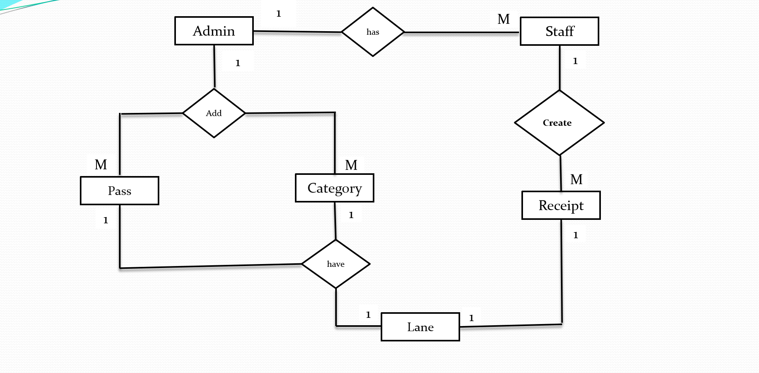

**Data flow Diagram**

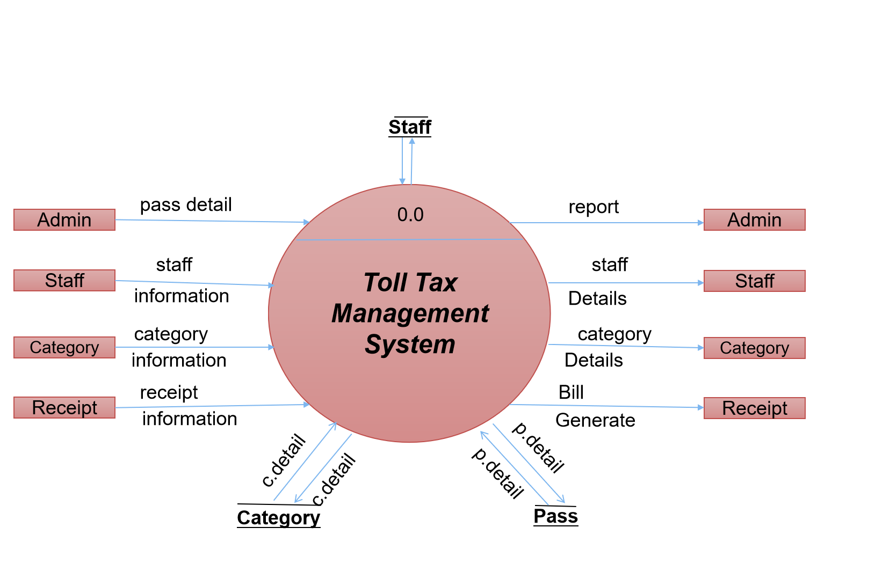

**Class Diagram**

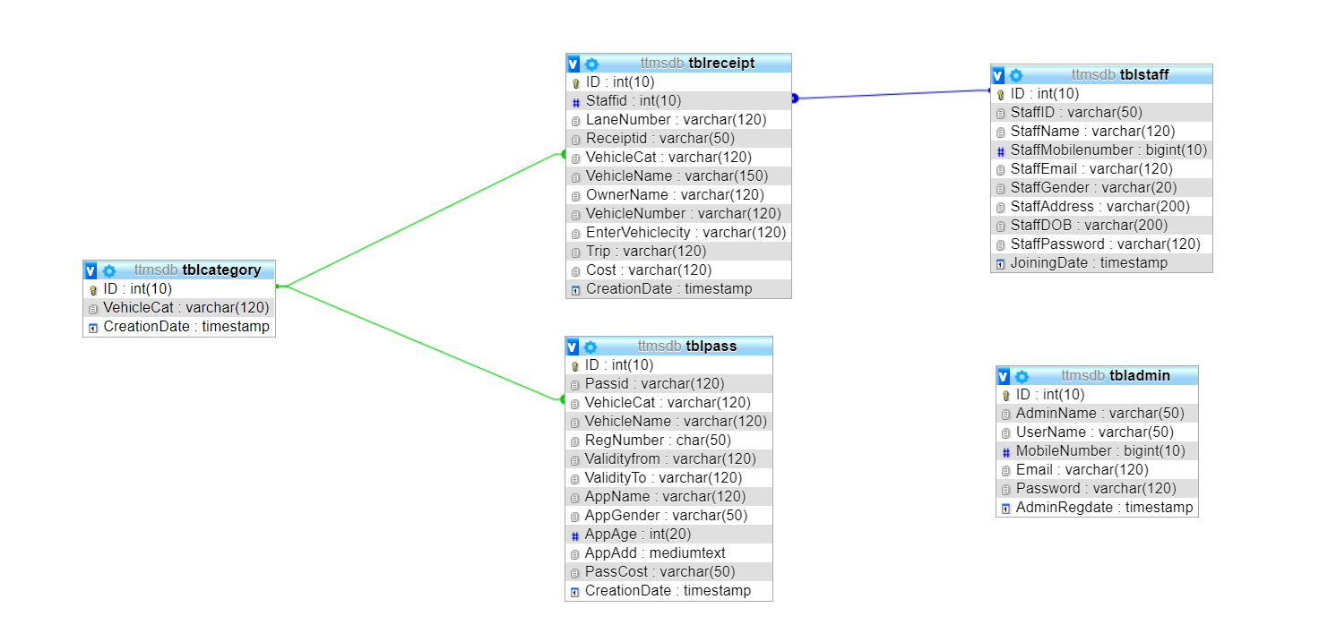

**Use Case Diagram**

Login

Dashboard

Manage staff

(Add/ Edit)

Search pass and receipts

Generate Reports

Update Own Profile

Change Password

Manage Vehicle category(Add/ Edit)

Manage Pass(Add/ Edit)

View Toll Receipts

**Use Case Diagram**

Login

Welcome Dashboard

Add Receipts

View Receipts

Search Receipts

Change Password

Update Own Profile

Password Recovery

**Activity Diagram**

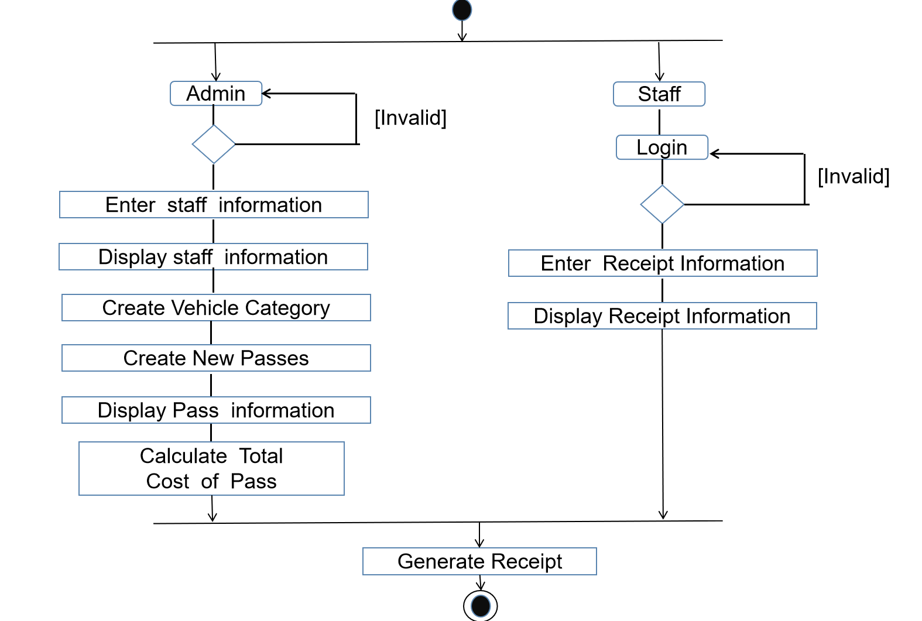

**Coading**

**Login Page**

**package toll;**

**import java.awt.Color;**

**import reset.*;**

**import java.awt.EventQueue;**

**import java.awt.Font;**

**import java.awt.Image;**

**import java.awt.event.ActionEvent;**

**import java.awt.event.ActionListener;**

**import java.awt.event.KeyAdapter;**

**import java.awt.event.KeyEvent;**

**import java.sql.Connection;**

**import java.sql.DriverManager;**

**import java.sql.ResultSet;**

**import java.sql.Statement;**

**import java.util.Map;**

**import javax.swing.ImageIcon;**

**import javax.swing.JButton;**

**import javax.swing.JFrame;**

**import javax.swing.JLabel;**

**import javax.swing.JOptionPane;**

**import javax.swing.JPanel;**

**import javax.swing.JPasswordField;**

**import javax.swing.JTextField;**

**import javax.swing.SwingConstants;**

**import javax.swing.border.EmptyBorder;**

**import java.awt.event.MouseAdapter;**

**import java.awt.event.MouseEvent;**

**import java.awt.font.TextAttribute;**

**public class login {**

**private JFrame frame;**

**JTextField textField,passwordField;**

**/\*\***

**\* Launch the application.**

**\*/**

**public static void main(String[] args) {**

**EventQueue.invokeLater(new Runnable() {**

**public void run() {**

**try {**

**login window = new login();**

**window.frame.setVisible(true);**

**} catch (Exception e) {**

**e.printStackTrace();**

**}**

**}**

**});**

**}**

**public login() {**

**initialize();**

**}**

**/\*\***

**\* Initialize the contents of the frame.**

**\*/**

**private void initialize() {**

**frame = new JFrame();**

**frame.setBounds(100, 100, 1920, 1080);**

**frame.setDefaultCloseOperation(JFrame.EXIT_ON_CLOSE);**

**JPanel panel = new JPanel();**

**panel.setLayout(null);**

**panel.setBounds(371, 90, 1138, 141);**

**panel.setBackground(new Color(0, 0, 0, 50));**

**frame.getContentPane().add(panel);**

**JLabel label = new JLabel("Toll Tax Management System");**

**label.setForeground(Color.BLACK);**

**label.setHorizontalAlignment(SwingConstants.CENTER);**

**label.setFont(new Font("URW Chancery L", Font.BOLD, 50));**

**label.setBounds(12, 12, 1114, 117);**

**panel.add(label);**

**JPanel panel_1 = new JPanel();**

**panel_1.setLayout(null);**

**panel_1.setBounds(530, 330, 846, 543);**

**panel_1.setBackground(new Color(0, 0, 0, 30));**

**frame.getContentPane().add(panel_1);**

**JLabel label_1 = new JLabel("LOGIN");**

**label_1.setForeground(Color.BLACK);**

**label_1.setHorizontalAlignment(SwingConstants.CENTER);**

**label_1.setFont(new Font("URW Chancery L", Font.BOLD, 40));**

**label_1.setBounds(161, 28, 492, 84);**

**panel_1.add(label_1);**

**JLabel label_2 = new JLabel("User Name");**

**label_2.setForeground(Color.BLACK);**

**label_2.setFont(new Font("Monospaced", Font.BOLD, 20));**

**label_2.setBounds(243, 155, 301, 41);**

**panel_1.add(label_2);**

**textField = new JTextField();**

**textField.setColumns(10);**

**textField.setBounds(243, 208, 301, 41);**

**textField.addKeyListener(new demo1());**

**panel_1.add(textField);**

**JLabel label_3 = new JLabel("Password");**

**label_3.setForeground(Color.BLACK);**

**label_3.setFont(new Font("Monospaced", Font.BOLD, 20));**

**label_3.setBounds(243, 261, 301, 41);**

**panel_1.add(label_3);**

**passwordField = new JPasswordField();**

**passwordField.setBounds(243, 314, 301, 41);**

**passwordField.addKeyListener(new demo1());**

**panel_1.add(passwordField);**

**JButton button = new JButton("Login");**

**button.setFont(new Font("Droid Serif", Font.PLAIN, 16));**

**button.addActionListener(new ActionListener() {**

**public void actionPerformed(ActionEvent ae) {**

**}**

**});**

**button.setBounds(204, 426, 140, 41);**

**button.addKeyListener(new demo1());**

**panel_1.add(button);**

**JButton button_1 = new JButton("Cancel");**

**button_1.setFont(new Font("Droid Serif", Font.PLAIN, 16));**

**button_1.addActionListener(new ActionListener() {**

**public void actionPerformed(ActionEvent e)**

**{**

**if(e.getSource()==button_1)**

**{**

**toll.main(null);**

**frame.setVisible(false);**

**}**

**}**

**});**

**button_1.setBounds(468, 426, 140, 41);**

**panel_1.add(button_1);**

**JLabel label_6 = new JLabel("Forgot Password");**

**Font font=label_6.getFont();**

**Map attribute=font.getAttributes();**

**attribute.put(TextAttribute.UNDERLINE,TextAttribute.UNDERLINE_ON);**

**label_6.setFont(font.deriveFont(attribute));**

**label_6.addMouseListener(new MouseAdapter() {**

**@Override**

**public void mouseClicked(MouseEvent e) {**

**Reset.main(null);**

**}**

**});**

**label_6.setForeground(Color.BLUE);**

**label_6.setFont(new Font("Droid Serif", Font.BOLD, 20));**

**label_6.setBounds(673, 507, 173, 24);**

**panel_1.add(label_6);**

**JLabel label_4 = new JLabel("Toll Tax Management Sysytem @2020");**

**label_4.setHorizontalAlignment(SwingConstants.CENTER);**

**label_4.setForeground(Color.DARK_GRAY);**

**label_4.setFont(new Font("Dialog", Font.BOLD, 17));**

**label_4.setBounds(581, 932, 739, 45);**

**frame.getContentPane().add(label_4);**

**JLabel label_5 = new JLabel("");**

**Image img=new ImageIcon(this.getClass().getResource("/pic.jpg")).getImage();**

**label_5.setIcon(new ImageIcon(img));**

**label_5.setBounds(12, 0, 1920, 1080);**

**frame.getContentPane().add(label_5);**

**}**

**public class demo1 extends KeyAdapter**

**{**

**public void keyReleased(KeyEvent ke)**

**{**

**if(ke.getSource()==textField)**

**{**

**if(ke.getKeyText(ke.getKeyCode())=="Enter")**

**{**

**passwordField.requestFocus();**

**}**

**}**

**else if(ke.getSource()==passwordField)**

**{**

**int flag=0;**

**String uname1,usname;**

**String pass,pwrd;**

**uname1=textField.getText();**

**pass=passwordField.getText();**

**if(ke.getKeyText(ke.getKeyCode()) == "Enter")**

**{**

**try**

**{**

**Connection con= null;**

**con =connection.getDBconnection();**

**Statement stmt=con.createStatement();**

**ResultSet rs=stmt.executeQuery("select * from login1");**

**while(rs.next())**

**{**

**usname = rs.getString("username");**

**pwrd = rs.getString("password"); if(uname1.equals(usname)&&pass.equals(pwrd))**

**{**

**flag=1;**

**JOptionPane.showMessageDialog(null,"login success");**

**frame.setVisible(false);**

**Dashboard.main(null);**

**break;**

**}**

**}**

**if(flag==0)**

**{ JOptionPane.showMessageDialog(null,"login fail");**

**textField.setText("");**

**passwordField.setText("");**

**}**

**}**

**catch(Exception e)**

**{**

**e.printStackTrace();**

**}}}}}}**

**Add Staff-**

**package toll;**

**import java.awt.EventQueue;**

**import javax.swing.JFrame;**

**import javax.swing.JLabel;**

**import javax.swing.JOptionPane;**

**import javax.swing.SwingConstants;**

**import javax.xml.crypto.Data;**

**import java.awt.Font;**

**import java.awt.Image;**

**import java.util.*;**

**import javax.swing.JTextField;**

**import javax.swing.JRadioButton;**

**import java.awt.Color;**

**import javax.swing.JPasswordField;**

**import java.awt.event.ActionListener;**

**import java.sql.Connection;**

**import java.sql.Date;**

**import java.awt.EventQueue;**

**import java.awt.EventQueue;**

**import java.sql.*;**

**import java.awt.*;**

**import javax.swing.*;**

**import java.awt.*;**

**import java.awt.event.*;**

**import java.awt.Color;**

**import java.awt.Font;**

**import java.awt.event.ActionListener;**

**import java.awt.event.KeyAdapter;**

**import java.awt.event.KeyEvent;**

**import java.io.InputStream;**

**import java.net.URL;**

**import java.net.URLConnection;**

**import java.sql.Connection;**

**import java.util.ArrayList;**

**import java.util.regex.Pattern;**

**import java.sql.DriverManager;**

**import java.sql.ResultSet;**

**import java.sql.Statement;**

**import java.text.SimpleDateFormat;**

**import java.time.LocalDate;**

**import java.time.Period;**

**import java.awt.event.ActionEvent;**

**import java.awt.event.*;**

**import net.proteanit.*;**

**import net.proteanit.sql.DbUtils;**

**import javax.swing.border.LineBorder;**

**import java.awt.Color;**

**import java.awt.Font;**

**import java.awt.event.ItemListener;**

**import java.awt.event.ItemEvent;**

**import java.awt.event.ActionListener;**

**import java.awt.event.ActionEvent;**

**import com.toedter.components.JLocaleChooser;**

**import com.toedter.calendar.JDateChooser;**

**import javax.swing.event.ListSelectionListener;**

**import javax.swing.event.ListSelectionEvent;**

**import javax.swing.event.ChangeListener;**

**import javax.swing.event.ChangeEvent;**

**import java.sql.DriverManager;**

**import java.sql.PreparedStatement;**

**import java.sql.ResultSet;**

**import java.sql.SQLException;**

**import java.sql.Statement;**

**import java.sql.Timestamp;**

**import java.time.LocalDate;**

**import java.awt.event.ActionEvent;**

**import javax.swing.ImageIcon;**

**import javax.swing.JButton;**

**import javax.swing.JComboBox;**

**import javax.swing.ComboBoxModel;**

**import javax.swing.DefaultComboBoxModel;**

**import com.toedter.calendar.JDateChooser;**

**public class addstaff {**

**private JFrame frame;**

**private JTextField textField_1;**

**private JTextField textField_2;**

**private JTextField txtgmailcom;**

**private JTextField textField_4;**

**JComboBox gender ;**

**JComboBox chckbxday,chckbxmonth,chckbxyear;**

**private JPasswordField passwordField_1;**

**private JTextField textField_5;**

**private JTextField dob;**

**JTextField staffid1;**

**JButton btnAdd,btnCancel;**

**/\*\***

**\* Launch the application.**

**\*/**

**public static void main(String[] args) {**

**EventQueue.invokeLater(new Runnable() {**

**public void run() {**

**try {**

**addstaff window = new addstaff();**

**window.frame.setVisible(true);**

**} catch (Exception e) {**

**e.printStackTrace();**

**}**

**}**

**});**

**}**

**/\*\***

**\* Create the application.**

**\*/**

**public addstaff() {**

**initialize();**

**}**

**/\*\***

**\* Initialize the contents of the frame.**

**\*/**

**private void initialize() {**

**frame = new JFrame("Add Staff");**

**frame.setBounds(110, 250, 1700, 760);**

**frame.getContentPane().setLayout(null);**

**//Statement s=null;**

**JLabel lblStaffId = new JLabel("Staff ID");**

**lblStaffId.setBounds(92, 23, 287, 35);**

**lblStaffId.setForeground(Color.BLACK);**

**lblStaffId.setFont(new Font("Dialog", Font.BOLD, 24));**

**frame.getContentPane().add(lblStaffId);**

**JLabel lblStaffName = new JLabel("Staff Name");**

**lblStaffName.setForeground(Color.BLACK);**

**lblStaffName.setBounds(91, 131, 287, 35);**

**lblStaffName.setFont(new Font("Dialog", Font.BOLD, 24));**

**frame.getContentPane().add(lblStaffName);**

**textField_1 = new JTextField();**

**textField_1.setFont(new Font("Droid Serif", Font.PLAIN, 20));**

**textField_1.setBounds(86, 175, 698, 42);**

**textField_1.setForeground(Color.BLACK);**

**textField_1.setBackground(Color.WHITE);**

**textField_1.setColumns(10);**

**frame.getContentPane().add(textField_1);**

**JLabel lblMobileNumber = new JLabel("Mobile Number");**

**lblMobileNumber.setForeground(Color.BLACK);**

**lblMobileNumber.setBounds(90, 229, 287, 35);**

**lblMobileNumber.setFont(new Font("Dialog", Font.BOLD, 24));**

**frame.getContentPane().add(lblMobileNumber);**

**textField_2 = new JTextField();**

**textField_2.setFont(new Font("Droid Serif", Font.PLAIN, 20));**

**textField_2.setBounds(86, 275, 698, 45);**

**textField_2.setForeground(Color.BLACK);**

**textField_2.setBackground(Color.WHITE);**

**textField_2.setColumns(10);**

**frame.getContentPane().add(textField_2);**

**JLabel lblEmail = new JLabel("E-mail");**

**lblEmail.setForeground(Color.BLACK);**

**lblEmail.setBounds(92, 331, 287, 35);**

**lblEmail.setFont(new Font("Dialog", Font.BOLD, 24));**

**frame.getContentPane().add(lblEmail);**

**txtgmailcom = new JTextField();**

**txtgmailcom.setFont(new Font("Droid Serif", Font.PLAIN, 20));**

**txtgmailcom.addActionListener(new ActionListener() {**

**public void actionPerformed(ActionEvent arg0) {**

**}**

**});**

**txtgmailcom.setBounds(86, 382, 698, 45);**

**txtgmailcom.setForeground(Color.BLACK);**

**txtgmailcom.setBackground(Color.WHITE);**

**txtgmailcom.setColumns(10);**

**frame.getContentPane().add(txtgmailcom);**

**JLabel lblAddress = new JLabel("Address");**

**lblAddress.setForeground(Color.BLACK);**

**lblAddress.setBounds(91, 439, 287, 35);**

**lblAddress.setFont(new Font("Dialog", Font.BOLD, 24));**

**frame.getContentPane().add(lblAddress);**

**textField_4 = new JTextField();**

**textField_4.setFont(new Font("Droid Serif", Font.PLAIN, 20));**

**textField_4.setBounds(86, 485, 698, 45);**

**textField_4.setForeground(Color.BLACK);**

**textField_4.setBackground(Color.WHITE);**

**textField_4.setColumns(10);**

**frame.getContentPane().add(textField_4);**

**JLabel lblPassword = new JLabel("Password");**

**lblPassword.setForeground(Color.BLACK);**

**lblPassword.setBounds(909, 120, 287, 35);**

**lblPassword.setFont(new Font("Dialog", Font.BOLD, 24));**

**frame.getContentPane().add(lblPassword);**

**JLabel lblGender = new JLabel("Gender");**

**lblGender.setForeground(Color.BLACK);**

**lblGender.setBounds(915, 440, 287, 35);**

**lblGender.setFont(new Font("Dialog", Font.BOLD, 24));**

**frame.getContentPane().add(lblGender);**

**JLabel lblDateOfBirth = new JLabel("Date of Birth");**

**lblDateOfBirth.setForeground(Color.BLACK);**

**lblDateOfBirth.setBounds(909, 276, 287, 35);**

**lblDateOfBirth.setFont(new Font("Dialog", Font.BOLD, 24));**

**frame.getContentPane().add(lblDateOfBirth);**

**JLabel label = new JLabel("Username");**

**label.setForeground(Color.BLACK);**

**label.setBounds(909, 23, 287, 35);**

**label.setFont(new Font("Dialog", Font.BOLD, 24));**

**frame.getContentPane().add(label);**

**passwordField_1 = new JPasswordField();**

**passwordField_1.setFont(new Font("Droid Serif", Font.PLAIN, 20));**

**passwordField_1.setBounds(905, 175, 698, 42);**

**passwordField_1.setForeground(Color.BLACK);**

**passwordField_1.setBackground(Color.WHITE);**

**frame.getContentPane().add(passwordField_1);**

**textField_5 = new JTextField();**

**textField_5.setFont(new Font("Droid Serif", Font.PLAIN, 20));**

**textField_5.setBounds(905, 69, 698, 45);**

**textField_5.setForeground(Color.BLACK);**

**textField_5.setColumns(10);**

**textField_5.setBackground(Color.WHITE);**

**frame.getContentPane().add(textField_5);**

**JDateChooser dateChooser = new JDateChooser();**

**dateChooser.setBounds(909, 343, 347, 45);**

**frame.getContentPane().add(dateChooser);**

**JComboBox chckbxgender = new JComboBox();**

**chckbxgender.setBounds(909, 485, 698, 45);**

**chckbxgender.setFont(new Font("Droid Serif", Font.PLAIN, 20));**

**chckbxgender.setModel(new DefaultComboBoxModel(new String[] {"Select", "Male", "Female", "Other"}));**

**frame.getContentPane().add(chckbxgender);**

**Image img1=new ImageIcon(this.getClass().getResource("/pic.jpg")).getImage();**

**btnAdd = new JButton("ADD");**

**btnAdd.setFont(new Font("Droid Serif", Font.PLAIN, 16));**

**btnAdd.setBounds(360, 621, 170, 45);**

**btnAdd.addActionListener(new ActionListener() {**

**public void actionPerformed(ActionEvent arg0) {**

**LocalDate localDate = LocalDate.now();**

**staffid1.setVisible(true);**

**String id=staffid1.getText();**

**String name=textField_1.getText();**

**String mobno=textField_2.getText();**

**String email=txtgmailcom.getText();**

**String address=textField_4.getText();**

**String username=textField_5.getText();**

**String pass=passwordField_1.getText();**

**String gender=chckbxgender.getSelectedItem().toString();**

**LocalDate d1=localDate;**

**//System.out.println(date);**

**if((!Pattern.matches("(0/91)?[7-9][0-9]{9}", textField_2.getText())))**

**{**

**JOptionPane.showMessageDialog(null,"Please Enter Valid Mobile Number","Invalid Mobile Number",JOptionPane.ERROR_MESSAGE);**

**}**

**else**

**if((!Pattern.matches("^[a-zA-Z0-9]+[@]{1}[a-zA-Z0-9]+[.]{1}+[a-zA-Z0-9]+$", txtgmailcom.getText())))**

**{**

**JOptionPane.showMessageDialog(null,"Please Enter Valid Email ID","Invalid Email ID",JOptionPane.ERROR_MESSAGE);**

**}**

**else**

**{**

**try**

**{**

**SimpleDateFormat sdf=new SimpleDateFormat("yyyy-MM-dd");**

**String date=sdf.format(dateChooser.getDate());**

**Connection con= null;**

**con =connection.getDBconnection();**

**Statement stmt=con.createStatement();**

**int result=stmt.executeUpdate("insert into staff(staffid,sname,mobileno,email,address,username,password,gender,dateofbirth,dateofjoin)"**

**+"values('"+id+"','"+name+"','"+mobno+"','"+email+"','"+address+"','"+username+"','"+pass+"','"+gender+"','"+date+"','"+d1+"')");**

**if(result==1) JOptionPane.showMessageDialog(null,"Record Insert Successfully");**

**staffid1.setText("");**

**textField_1.setText("");**

**textField_2.setText("");**

**txtgmailcom.setText("");**

**textField_4.setText("");**

**textField_5.setText("");**

**passwordField_1.setText("");**

**}**

**catch (Exception e) {**

**JOptionPane.showMessageDialog(null, "Invalid Details", "Error", JOptionPane.ERROR_MESSAGE);**

**}**

**}**

**}**

**});**

**frame.getContentPane().add(btnAdd);**

**JButton btnUpdate = new JButton("UPDATE");**

**btnUpdate.setFont(new Font("Droid Serif", Font.PLAIN, 16));**

**btnUpdate.addActionListener(new ActionListener() {**

**public void actionPerformed(ActionEvent arg0) {**

**managestaff.main(null);**

**}**

**});**

**btnUpdate.setBounds(699, 621, 170, 45);**

**frame.getContentPane().add(btnUpdate);**

**staffid1 = new JTextField();**

**staffid1.setForeground(Color.BLACK);**

**staffid1.setFont(new Font("Droid Serif", Font.PLAIN, 20));**

**staffid1.setColumns(10);**

**staffid1.setBackground(Color.WHITE);**

**staffid1.setBounds(86, 55, 698, 45);**

**//staffid1.setVisible(false);**

**frame.getContentPane().add(staffid1);**

**btnCancel = new JButton("CANCEL");**

**btnCancel.addActionListener(new ActionListener() {**

**public void actionPerformed(ActionEvent e) {**

**if(e.getSource()==btnCancel)**

**{**

**frame.setVisible(false);**

**}**

**}**

**});**

**btnCancel.setFont(new Font("Droid Serif", Font.PLAIN, 16));**

**btnCancel.setBounds(1030, 621, 170, 45);**

**frame.getContentPane().add(btnCancel);**

**JLabel label_1 = new JLabel("");**

**label_1.setBounds(0, 0, 1700, 760);**

**Image img=new ImageIcon(this.getClass().getResource("/pic.jpg")).getImage();**

**label_1.setIcon(new ImageIcon(img));**

**frame.getContentPane().add(label_1);**

**}**

**Output**

**Home Page**

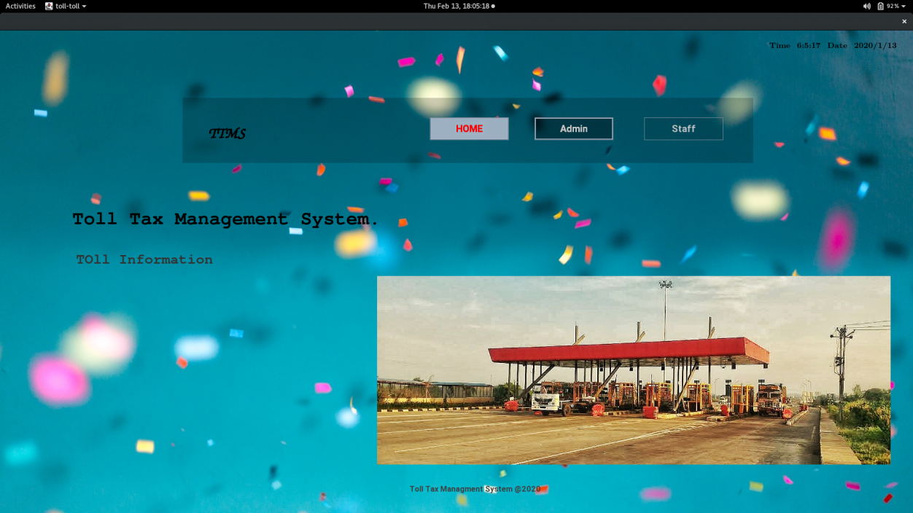

**Admin Login**

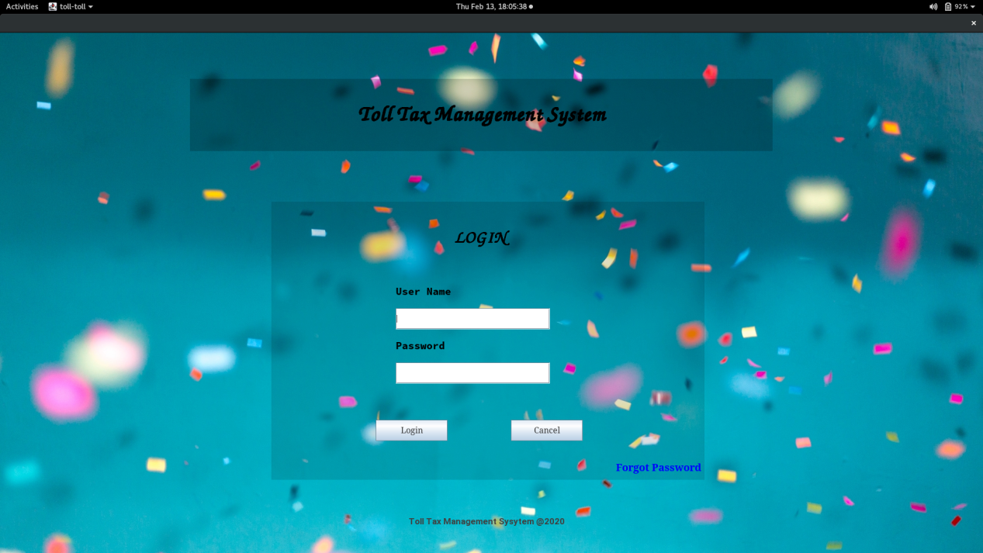

**Dashboard**

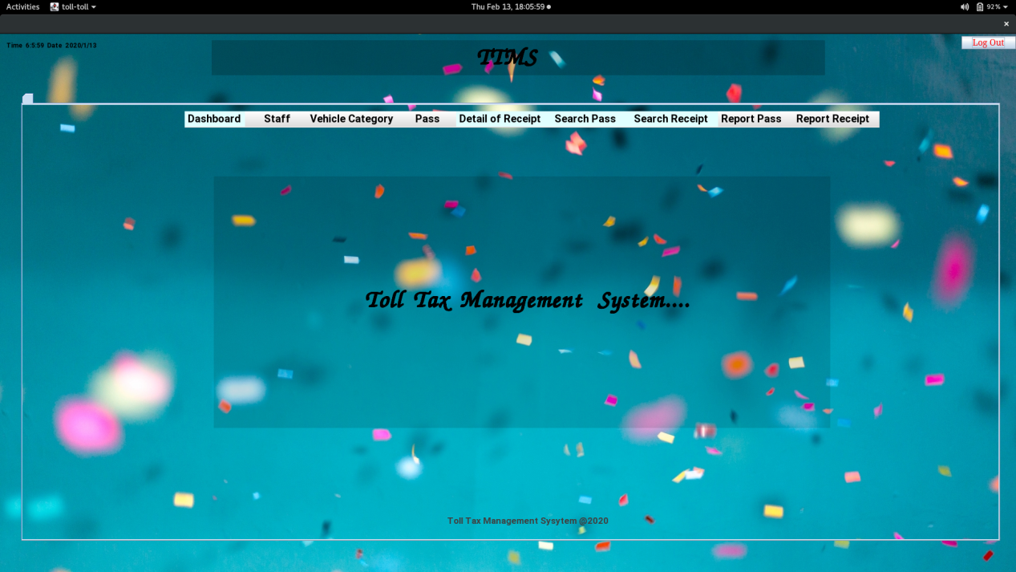

**Add Staff**

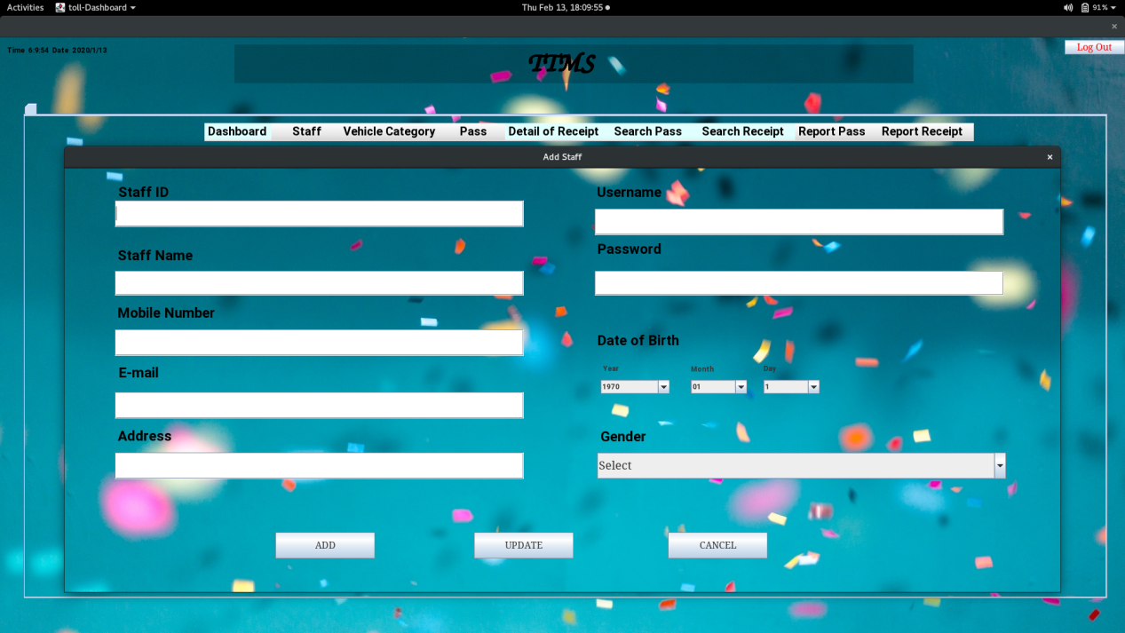

**Staff Details**

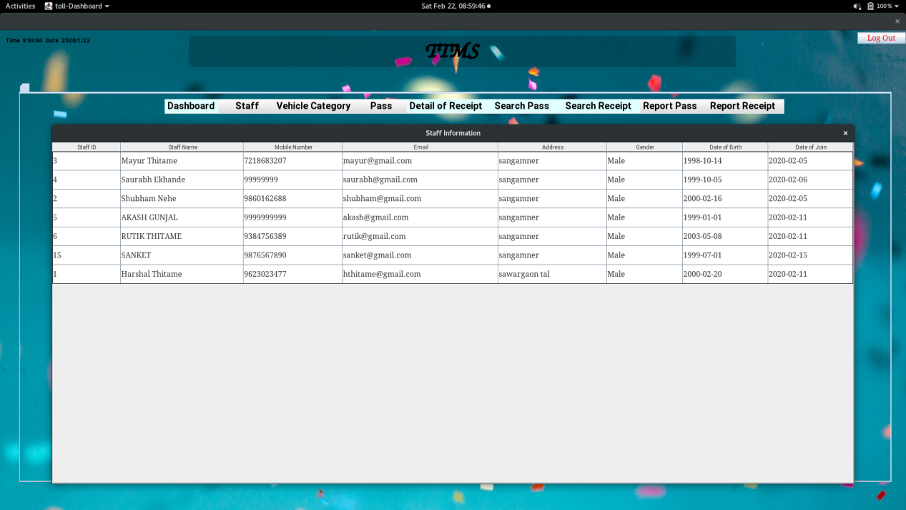

**Update Staff Information**

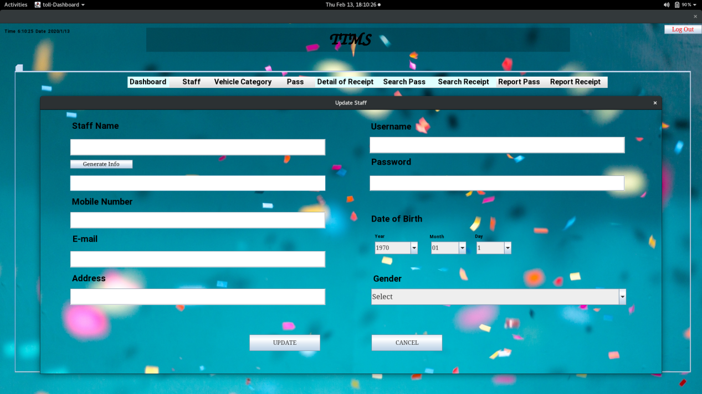

**Delete Staff**

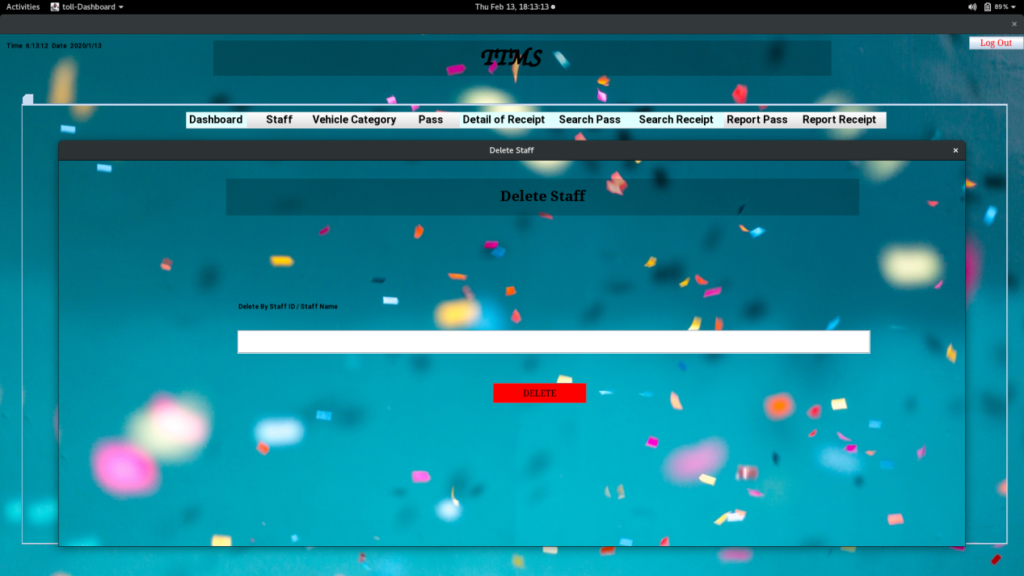

**Add Pass**

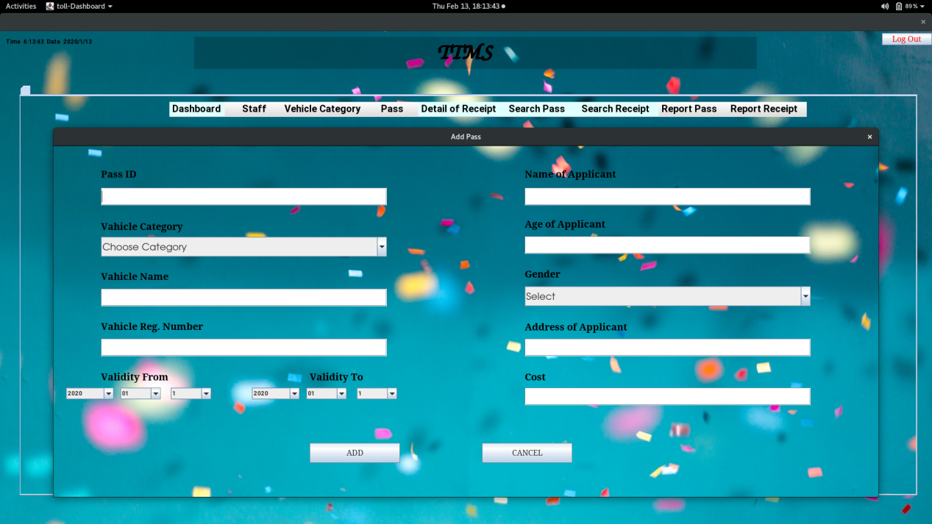

**Pass Details**

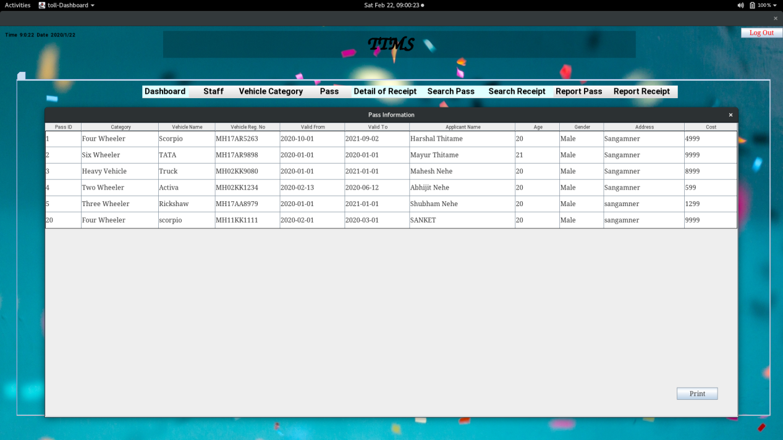

**Delete Pass**

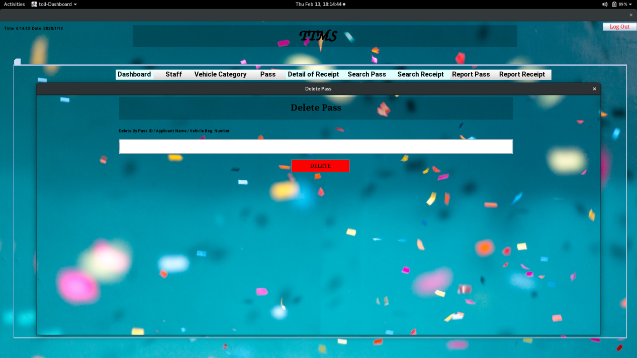

**Search Pass**

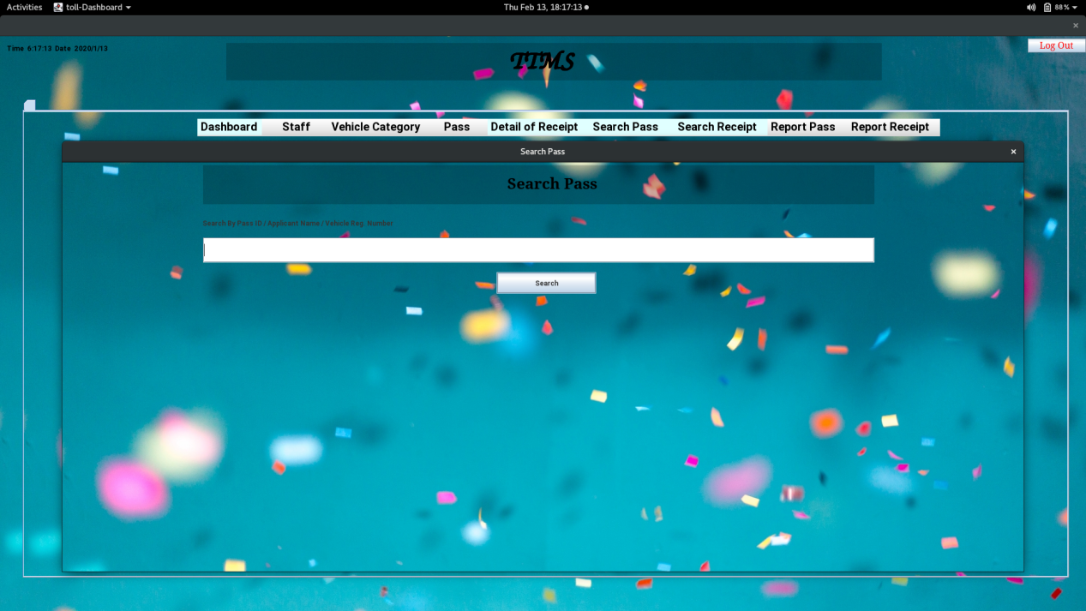

**Search Receipt**

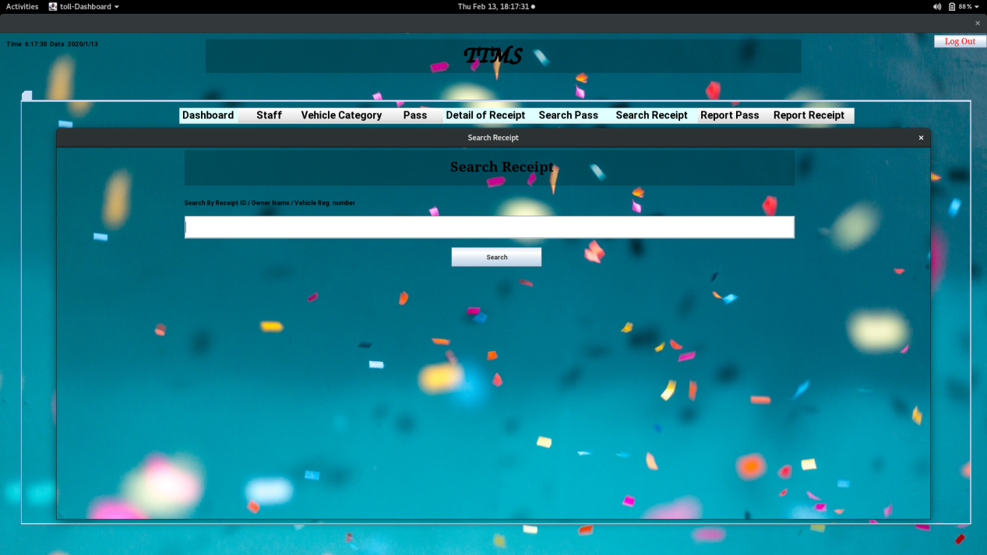

**Receipt Details**

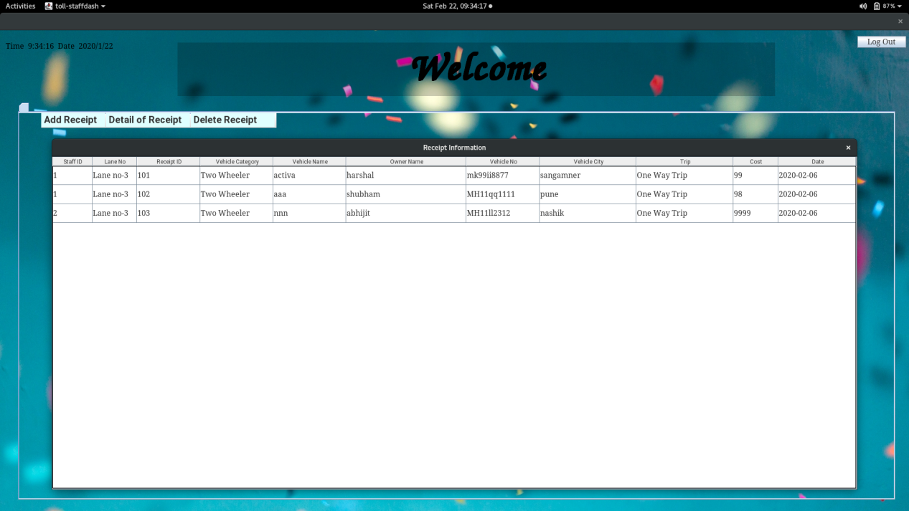

**Staff Login**

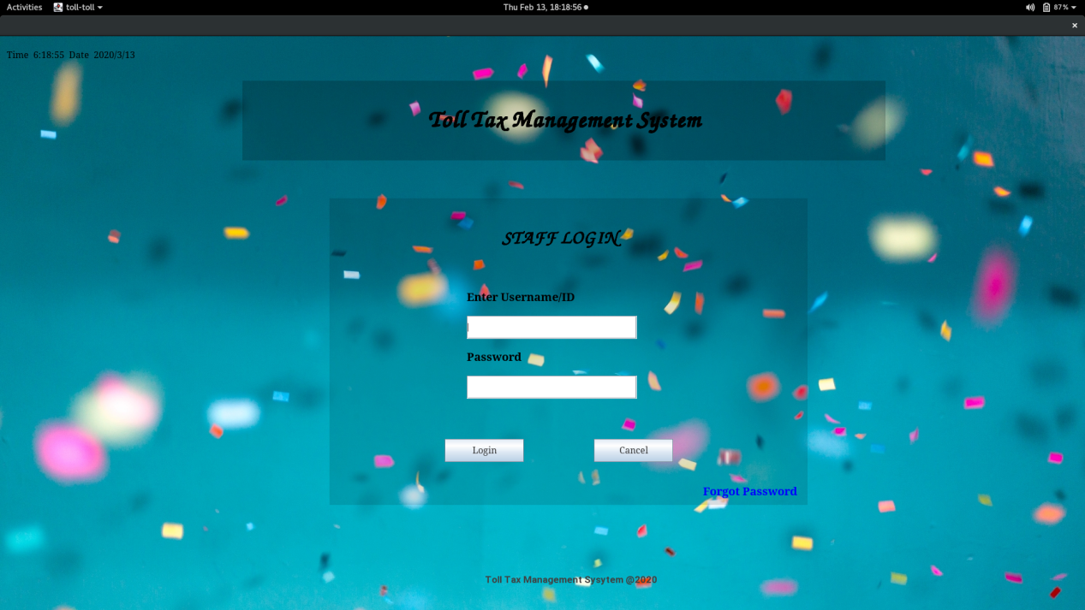

**Category Details**

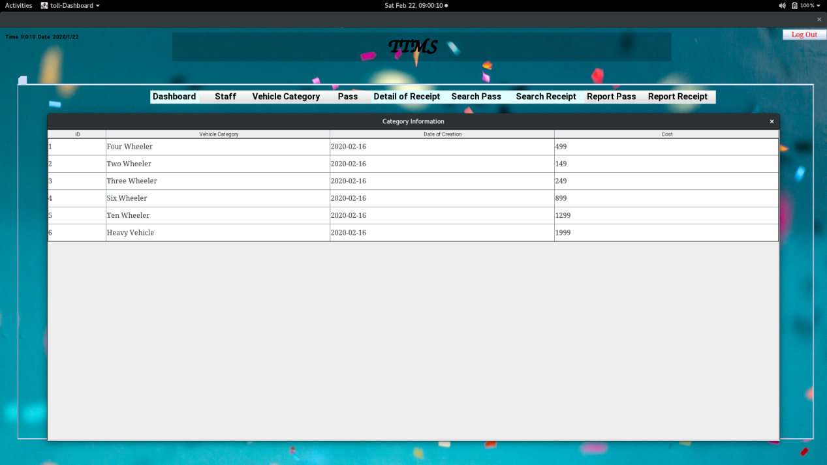

**Pass Count**

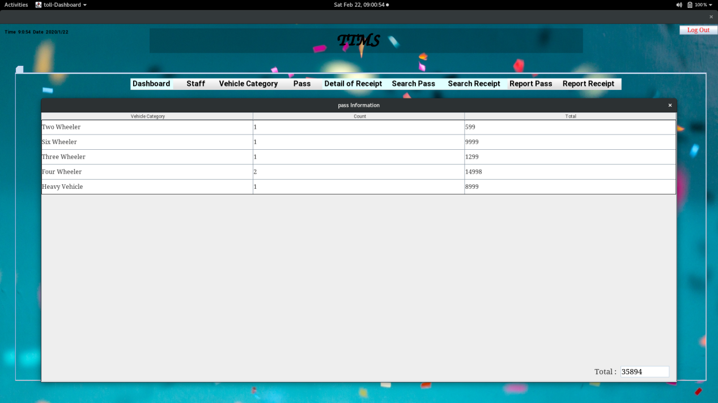

**Receipt Count**

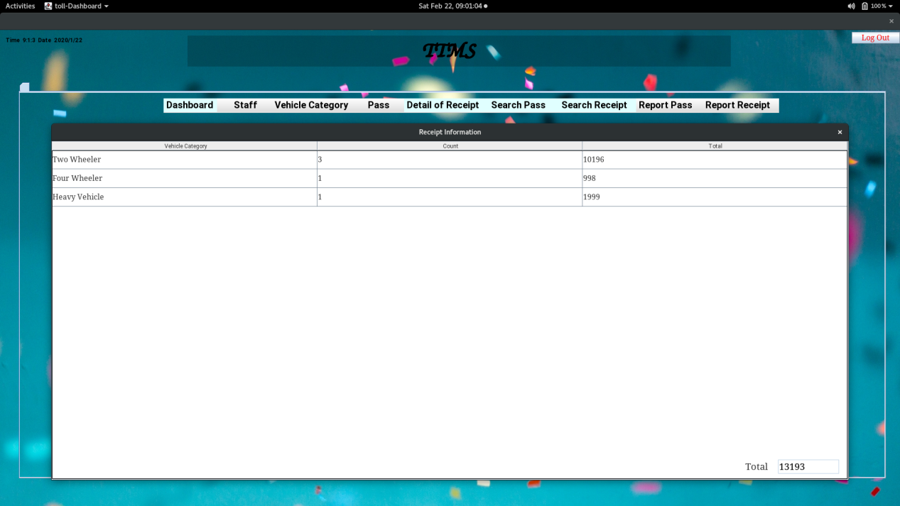

**Staff Dashboard**

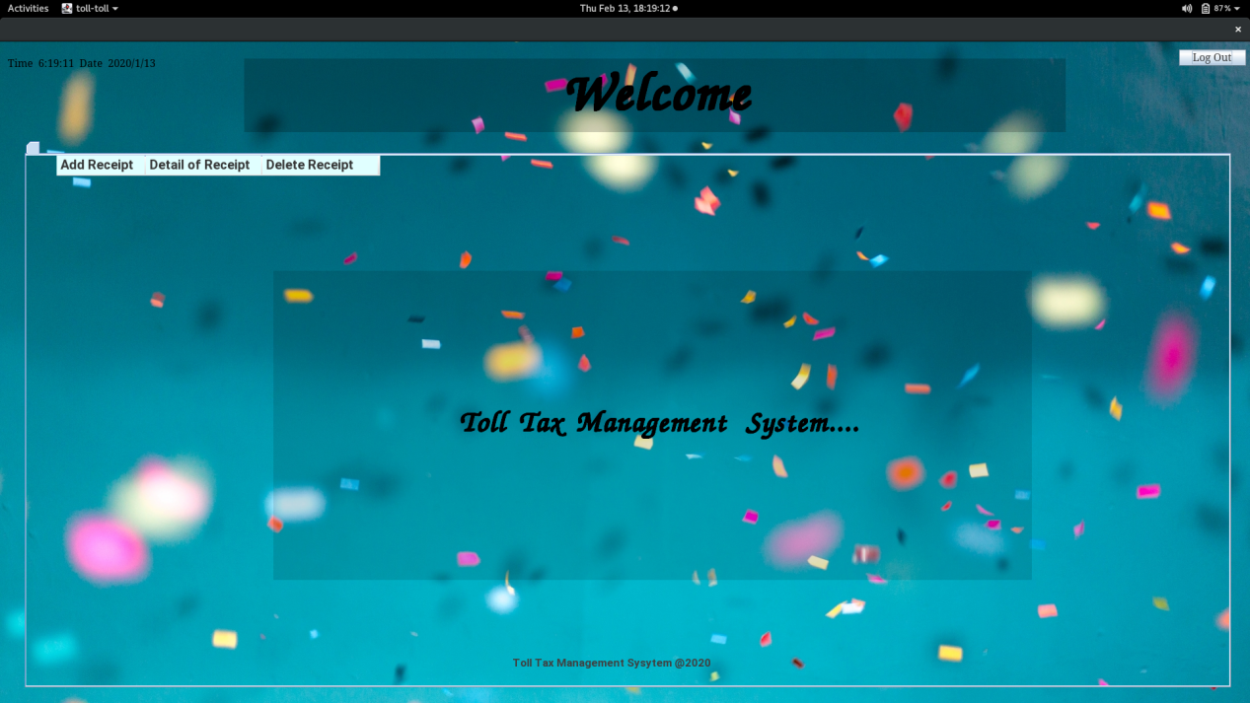

**Add Receipt**

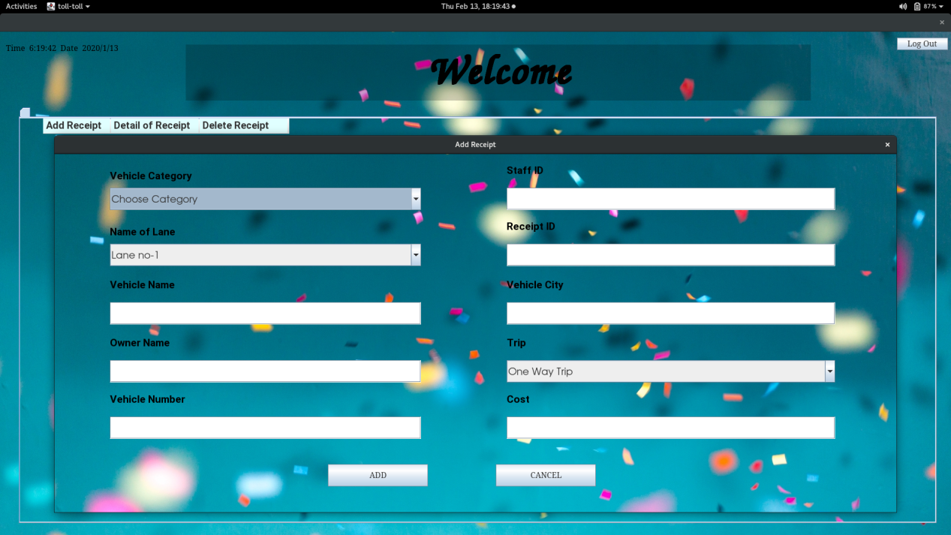

**Delete Receipt**

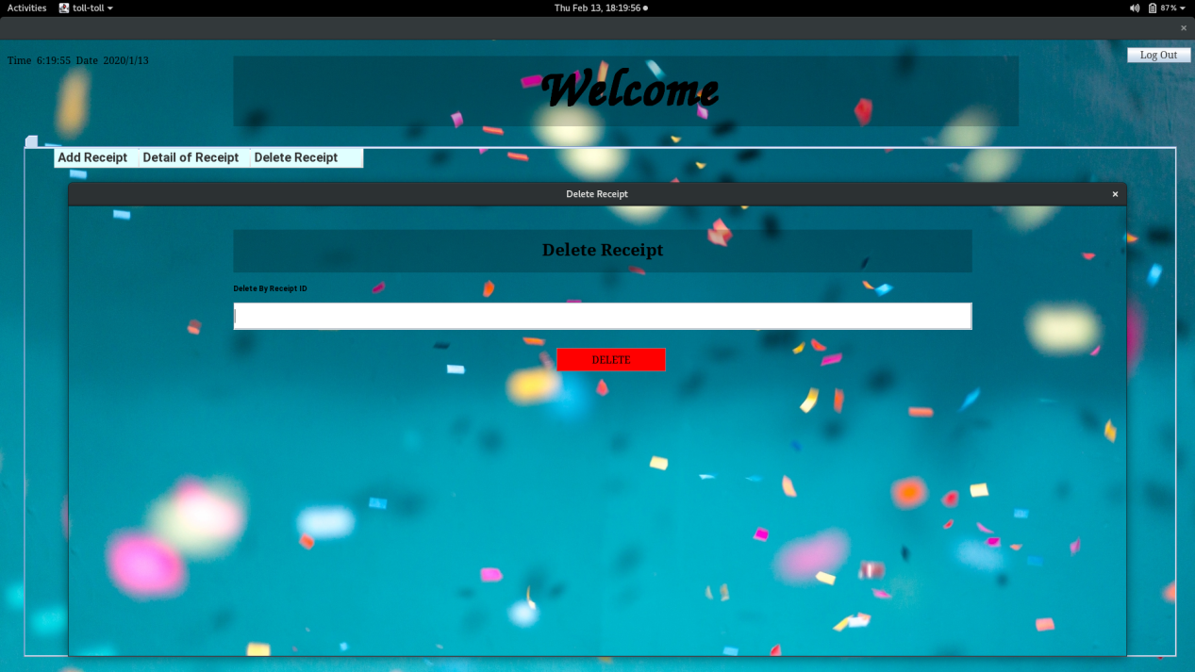

**Forgot Password Admin**

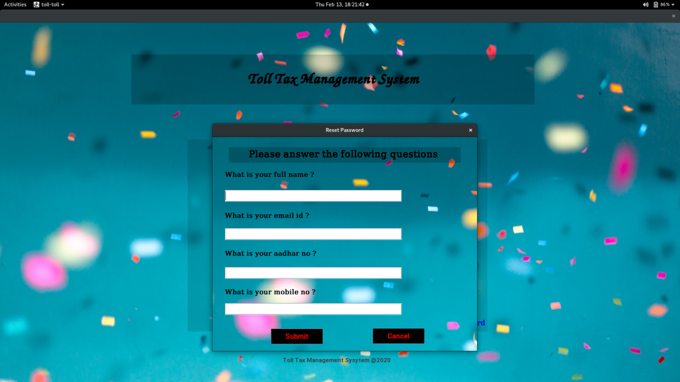

**Forgot Password Staff**

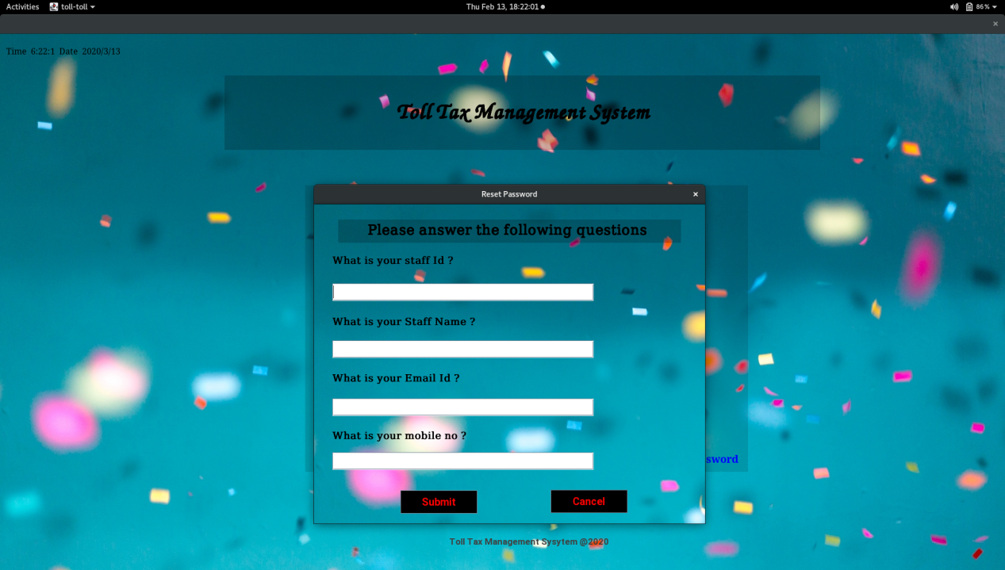

**Future Enhancement**

* Implementation of BAR code Reader.
* Provide more online tips & help.
* SMS notification after registration, payment & next maturity date.
* Encrypted web page to ensure customer privacy & transaction security.
* More functionality can be added depending upon the user requirements & specification.
* The project can be expanding as per the need of the company & if there will any more requirements that can be satisfy.

**Advantages**

* This project offers user to enter the data through simple and interactive forms. This is very helpful for the client to enter the desired information through so much simplicity.
* User friendly.
* Secure because of authentication.
* Customer can make payment by cash or credit
* Easy Purchase entry.
* System maintain item stock and stock alert.

**Conclusion**

**Bibliography**

**Book:**

### [Programming C# 5.0: Building Windows 8, Web, and Desktop Applications for the .NET 4.5 Framework](http://amzn.to/1NKnxtZ" \o "Programming C# 5.0: Building Windows 8, Web, and Desktop Applications for the .NET 4.5 Framework)

### - **By: Ian Griffiths**

* Component-Based Development with Visual C# (M&T books)  -

-Ted Faison

* Dot Net 4.0 Programming 6 In 1 Black Book

- kogent Learning solution inc.

* The unified modeling language user guide

-Grady Booch

**Website:**

[www.msdn.com](http://www.msdn.com/)  
 [www.w3school.com](http://www.w3school.com/)

[www.stackoverflow.com](http://www.stackoverflow.com)